E3文件夹下的数据为如下的例子:

The data included in E3 file are used for the following example:

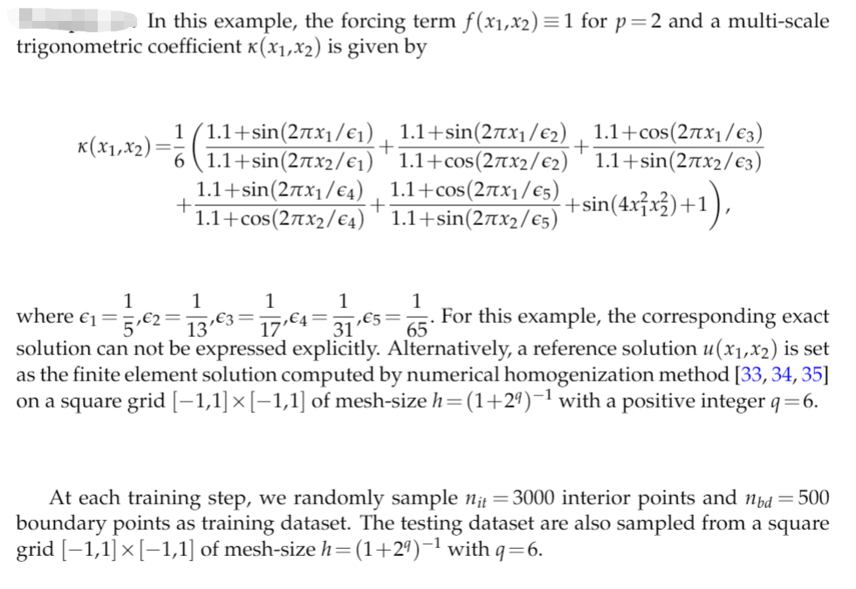

E4文件夹下的数据为如下的例子:

The data included in E4 file are used for the following example:

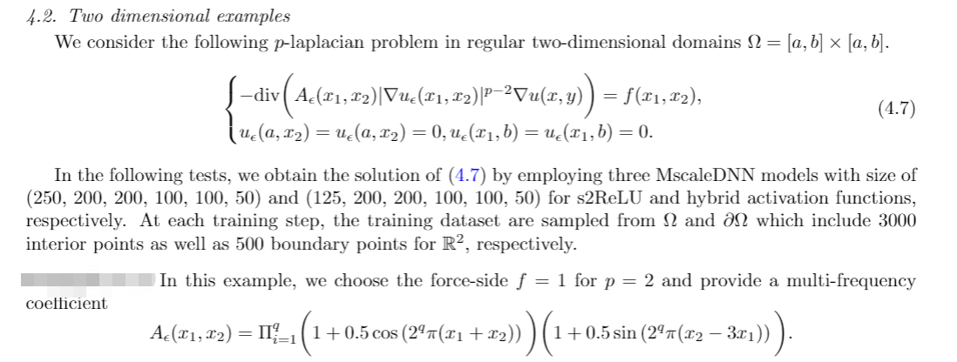



E5文件夹下的数据为如下的例子:

The data included in E5 file are used for the following example:

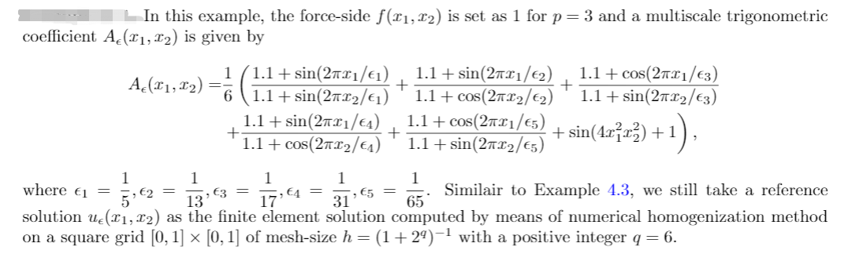

E6文件夹下的数据为如下的例子:

The data included in E6 file are used for the following example:



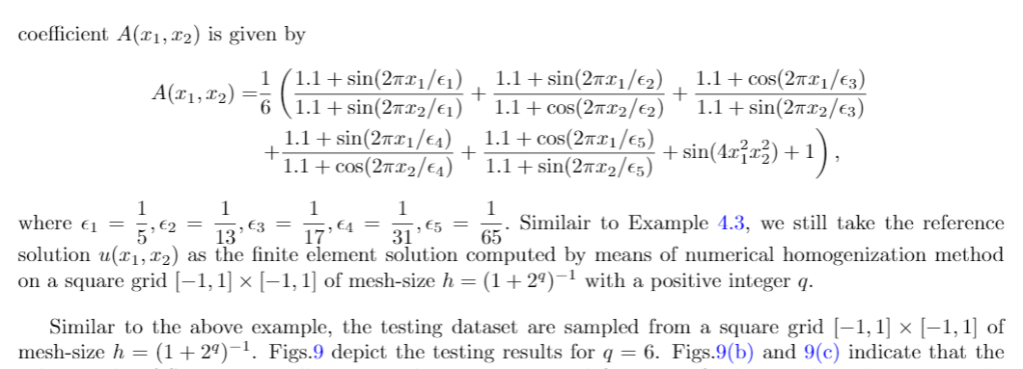

Note:

Except for E5，the domain of other examples are all [-1,1]x[-1,1]